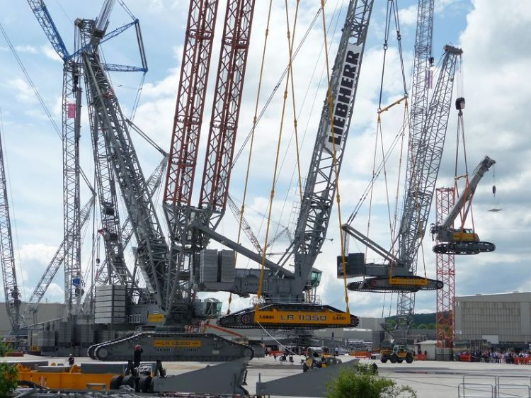

Assessment task 3 – Contract preparation and administration

By

Linchong Pan

100571672

Select and Prepare A Construction Contract

CPCCBC4003A

Submission date

Saturday, 6 October 2018

The date field is called a dater and is also active, just click and a date picker control box will appear

# Contents

Contents ii

Table of Figures ii

1 Introduction 1

1.1 Purpose of assessment 1

1.2 Assessment task 1

2 Construction project 1

2.1 Sourcing appropriate expert advice in contract preparation 2

2.2 Scheduling progress payments 2

2.3 Inclusion of specifications in the contract regarding termination of the contract 3

2.4 Contract preparation – calculation of rise and fall 3

2.5 Contract administration requirements 3

2.6 Extension of time application 5

2.7 Finalisation of contract documentation 5

3 Conclusion 6

4 References 7

# Table of Figures

Figure 1 Preview of final project 4

Figure 2 Full diagram 6

# Introduction

## Purpose of assessment

To provide evidence of preparation and contract administration of a low-rise construction contract.

## Assessment task

Choose an actual low-rise construction project/site. Using this project/site, provide evidence, which clearly demonstrates that you are able to prepare a building contract, which is appropriate for low-rise construction.

You must provide sufficient evidence that meets the purpose of assessment as described. As a minimum, discussion must cover:

* sourcing appropriate expert advice in contract preparation
* scheduling progress payments
* inclusion of specifications in the contract regarding termination of the contract
* contract preparation – calculation of rise and fall
* contract administration requirements
* extension of time application
* finalisation of contract documentation.

# Construction project

1045 Whitehorse Road, Box Hill VIC 3128 (Urban.com.au, 2018)

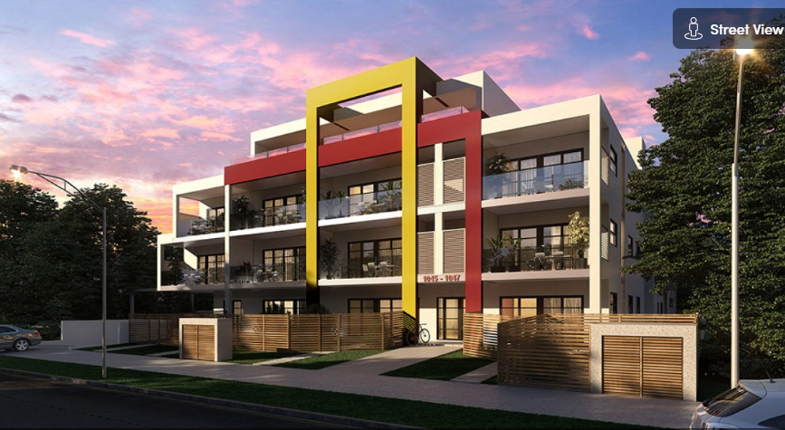

Figure Preview of final project

|  |  |
| --- | --- |
| Project Type | Residential |
| Floor Count | 4 |
| Number of Buildings | 1 |
| Building Type | Low-rise |
| Number of Residences | 35 |

## Sourcing appropriate expert advice in contract preparation

Before the initialising of this project, advices from experts are required to avoid mistakes from inexperience. People with previous experiences can make more accuracy estimations. In addition, the builder should also seek advices from legal practitioners to prevent possible legal issues during the contract preparation.

## Scheduling progress payments

According to Consumer Affairs Victoria, the builders should set the amount for the deposit, defines the stages of building and how much the consumers should pay for each stage, and the changes only apply when changes stated in contract.

Therefore, in this project, the payment should follow the table below

|  |  |  |
| --- | --- | --- |
|  |  | Amount (Total amount 110,000) |
| Deposit | 5% | 5,500 |
| 1st stage payment | 15% | 16500 |
| 2nd stage payment | 25% | 27500 |
| 3rd stage payment | 25% | 27500 |
| 4th stage payment | 15% | 16500 |
| Final payment | 15% | 16500 |

## Inclusion of specifications in the contract regarding termination of the contract

According to the Building Act 1993, both Building Owner and the Builder required to notify the building surveyor for the Work within 14 days after the engagement of the Builder ends by termination of the contract.

Failure to give notifications can incur a maximum penalty of 10 penalty units. Before termination the Building Owner should discuss with the building surveyor the possibility to continue the Work once the contract with the Builder is terminated and the process required for notification of appointment of a subsequent builder.

If the Building Owner does not intend to complete the Work, either by appointing another builder or completing the Work themselves, the Building Owner should discuss with the relevant building surveyor how this affects compliance with the requirements of the Building Act 1993 and any subsequent prescribed approval.

(Victoria, 2018)

## Contract preparation – calculation of rise and fall

Consider the construction duration for this project is around 1 year,

Rise and fall % = [(the index of Sept 2019 – the index of Sept 2018) / (the index of Sept 2018)] x 100.

In addition, labour changes from government and the material price changes also need to be reflected in this calculation.

## Contract administration requirements

There are several major steps to perform contract administration requirements:

* Collet the client’s requirements and give possible solutions
* Feasibility study

This is study against unrealistic or over-budget designs, in this project, the customers want to build 5 stories building which is not permit from local city council.

* Initial design (Drawing)
* Full design (Drawing)

The drawing then used as the standard of contract and the onsite instruction

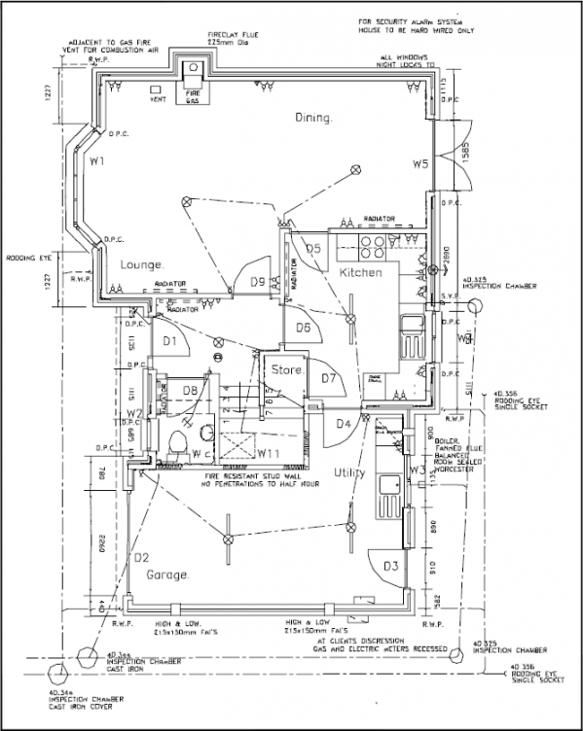

Figure Full diagram

* planning, Building Regulation
* obtaining competitive tenders
* commencement on-site
* monitoring of the program of work, quality of work and costs
* identification of poor working practices, defects and damage

## Extension of time application

The builder will be entitled to extension of time, if

* The weather and its effect over and above the days estimated by the builder during the contract
* An industrial dispute that not controlled by the builder (for example, material standard changes)
* There are some defects that affects the overall project

## Finalisation of contract documentation

During the finalisation of contract documentation stage, any gaps or deficiencies can then be identified and appropriate actions implemented, and the other related documents. As the end of contract preparation, all the questions should be answered and placed in the contract. In addition to these, the payment and quality standard also need to mentioned in to contract to avoid problems.

# Conclusion

This assignment provides a way to understand how to prepare a construction contract at the preparation stage, understanding the contents of a suitable contract and how to initialise the project based on this contract.

# References

Australia Standards, 1992. *AS2124 General Conditions of Contract,* Sydney: SAI global.

Australia Standards, 2002. *AS4915 Project Management,* Sydney: SAI global.

Australian Standards, 2002. *AS 1170 0.1 Structural Design Actions Part one: Permanent, Imposed and Other Actions,* Sydney: SAI global..

SAI global, 2004. *HB 240-2004 Guidelines for managing risk in outsourcing,* Canberra: s.n.

SAI global, 2004. *HB 436: 2004 Risk management guidelines companion to AS 4360: 2004,* Canberra: s.n.

Urban.com.au, 2018. *1045 Whitehorse Road, Box Hill VIC 3128.* [Online]   
Available at: https://www.urban.com.au/projects/whitehorse-3128-1045-whitehorse-road-box-hill

Victoria, C. A., 2018. *Building contracts.* [Online]   
Available at: https://www.consumer.vic.gov.au/housing/building-and-renovating/plan-and-manage-your-building-project/contracts